
DV Client Delete Annotation

Revision History

1.0 | Ricky

Description:
This document describe the logic of how to edit / delete annotation in DaVinci client or DaVinci compare client.

Purpose:
Provide API to third party system edit / delete annotation in DaVinci client or DaVinci compare client

Function:
- End user can edit / delete annotation only when he had the right to create new annotation;
- End user can only edit / delete his own annotation;
- If the annotation which would be edited / deleted, belong to a certain task, then end user can edit / delete this annotation before this task is closed. Note that this function need to work with third party system.

Detail:
- In a certain session, edit / delete annotation should be with create new annotation, Picture 1 shows that when end user had the right to create new annotation, he can edit / delete annotation; Picture 2 shows create new annotation function is disable, then edit / delete annotation also disable.
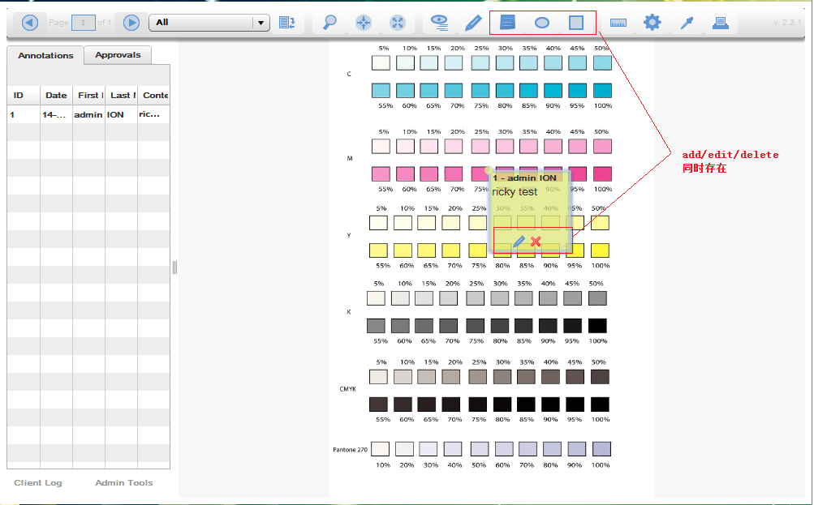
Picture 1
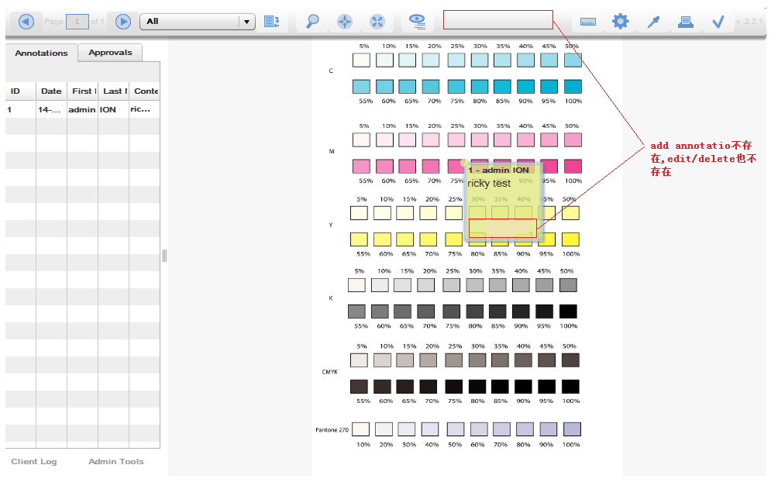
Picture 2
- End user can only edit / delete annotations which was created by his own, below screen shot shows the current login user is admin, so the annotation created by Jerry can not be edited / deleted by admin.
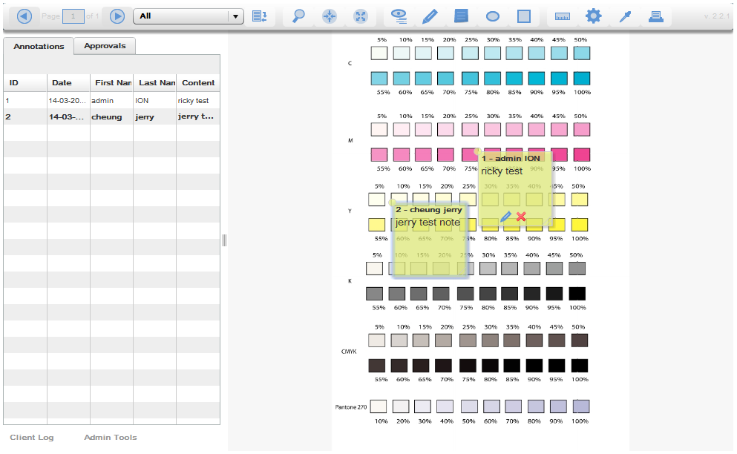

- 用户只可以修改和删除她最后一次approval之后添加的annotation。如下图所示，admin 第一次打开添加了两个annotation 1&2,然后关闭图片，第二次打开时又添加了一个annotation 3，接着将图片设置了状态。第三次她再打开该图片时，她就不能对annotation1、2&3进行修改和删除，但如果她此时又向图片添加了annotation 4,她可以对annotation 4进行修改和删除。
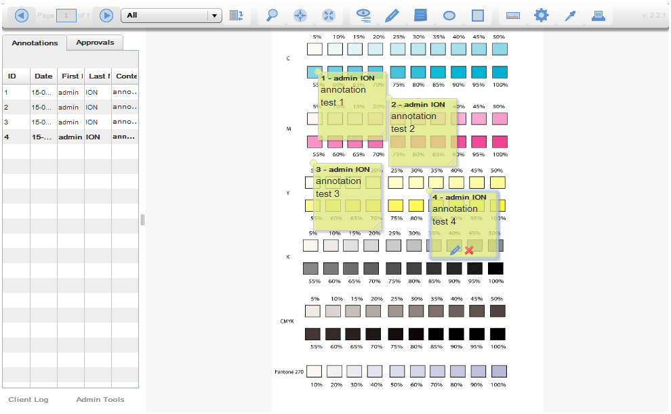
四 功能实现
目前判断annotation是否能够删除以及是否能够添加的逻辑是在Client进行判断的.服务端只负责保存annotation的信息，用户可以通过设置approval状态后会自动调用setNotesStatus方法，或者通过直接调用webservice的setNotesStatus和setNoteStatus 方法设置相应annotation的lock状态,taskID的值.

- Delete annotation workflow:
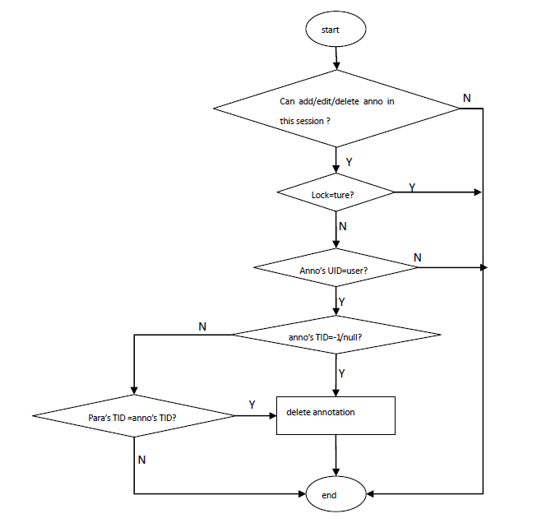
- Set annotation status workflow
